Contact Book Management System
Project Title: Contact Book Management System (Python Mini Project)
Project Description: The Contact Book Management System is a menu-driven Python console application designed to store and manage contact information efficiently. The system allows users to view, search, add, and save contact details using basic Python programming concepts. This project demonstrates the practical use of lists, dictionaries, functions, loops, conditionals, exception handling, and file handling.
Features :
- Pre-loaded 10 contact records
- View all contacts
- Search contact by name
- Add a new contact
- Save contact data to a file
- Menu-driven program using a loop
- Handles invalid user input gracefully
Concepts Used :
- List (to store multiple contacts)
- Dictionary (to store individual contact details)
- User-defined functions
- While loop
- Conditional statements (if / elif / else)
- String methods (lower(), strip())
- List methods (append(), len())
- Dictionary methods (items())
- Exception handling (try / except)
- File handling using open() and with open()
- Import statement (os module)

How to Run the Program :
1.Ensure that Python is installed on your computer.
2.Save the program file with the name.
3.Open the file using any Python-supported editor such as IDLE, PyCharm, VS Code, or Thonny.
4.Run the program by clicking the Run button in the editor or pressing the run option provided by the software.
5.The menu will appear on the screen.
6.Enter the required option number to perform actions like adding, viewing, or searching.
Input Guidelines :
- Contact ID must be a numeric value.
- Name, Phone, and City should be entered as text.
- While searching, enter the exact name (case-insensitive).
- Choose menu options only from the given numbers.
File Handling Details :
- Expense data is saved to a file named contacts.json
- The file is created automatically if it does not exist
- Data is stored in JSON format for easy readability and reuse
Testing and screenshots :
Useful test scenarios
- View all contacts:
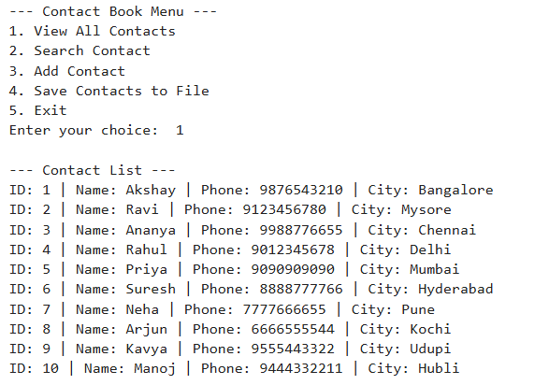

- Search contact:
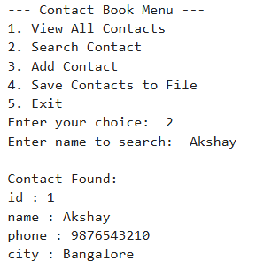

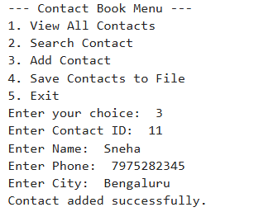
- Add contact:

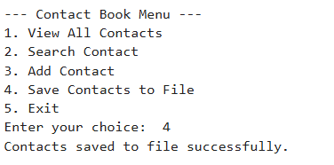
- Save contact to file:

Author Information :
Name: Akshay Rakshit.
Course: AI & ML For Financial services.
Project Type: Python Mini Project.

